FACULTY EVALUATION
Programme Name: SBVP ALUMNI MASTERCLASS - GROW Online Tanzania (23rd March 2026 - 27th March 2026)
Session: Social impact measures and planning
Faculty Name: Dr. Isaac Muiruri Gachanja
No. of Respondents: 9
No. of Participants: 10
Evaluation Parameter | (%) Individual Score | (%) Programme Average
Punctuality (Commencement and Completion of Sessions) | 94 | 96
How well do you understand the core concepts presented? | 97 | 95
Rate your confidence in applying the new skills learnt | 94 | 95
Degree of Faculty preparedness for the sessions | 97 | 96
Content and methodology of the program | 97 | 97
Quality of class and group discussions | 97 | 95
The information presented in the course is relevant to my work (ministry) | 91 | 94
Average scores | 95 | 95

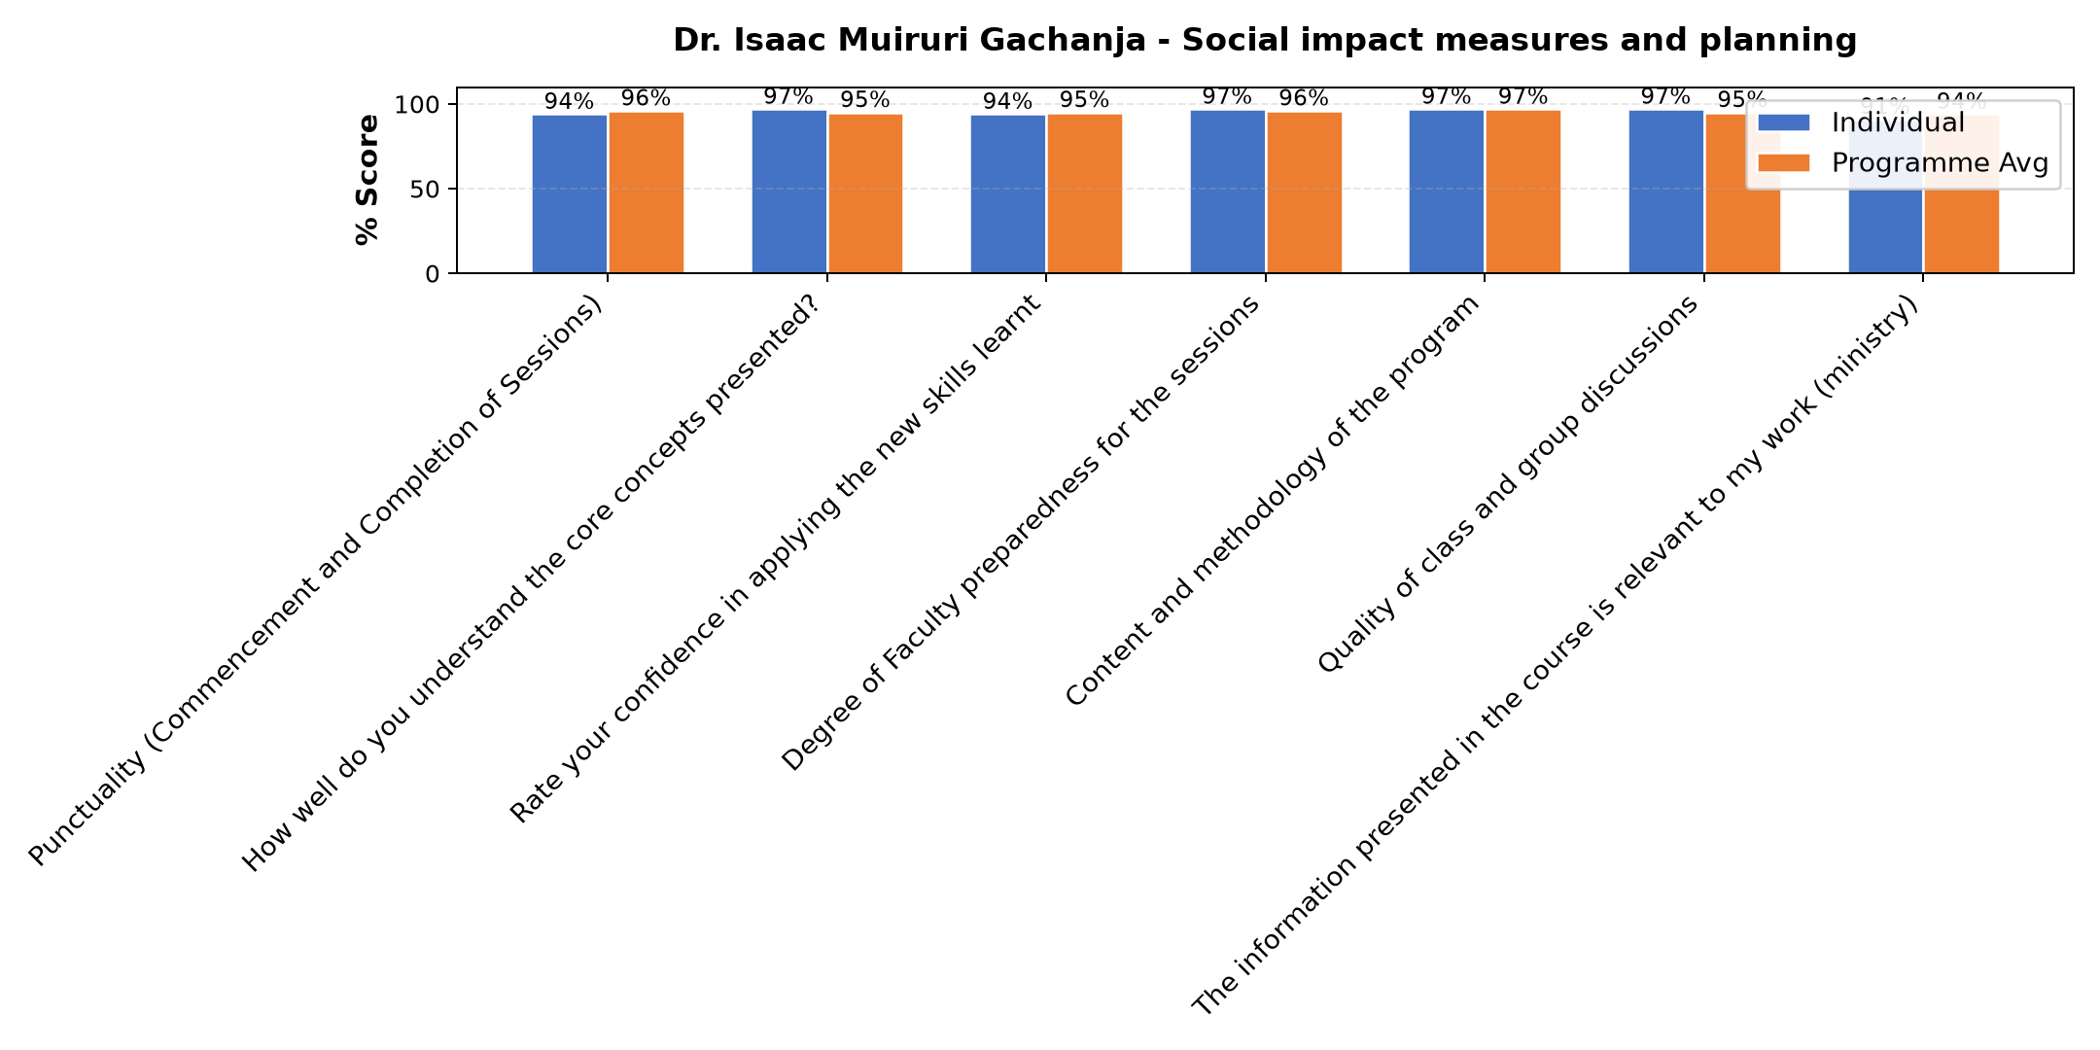

Comments & Feedback
- • Poor collaboration with the Donors
- • Financial
- • Sr Adorata
- • When the authority does not give me the ministry to practice what I have learnt
- • Well presented and understood
- • Internate problem during session
- • Thanks
- • The presentation was good.
- • Very professional presented
SUBMITTED THROUGH:
SBS Evaluation Automation System

